**Requirement Analysis Document: Student Management System (Java CLI OOP Project)**

**Objective**

Design and implement a command-line application that manages student academic activities using all core Object-Oriented Programming (OOP) principles. The system consists of two user modules: Admin and Student.

**Functional Requirements**

**Admin Module:**

* Admin login with password
* Add academic branches
* Add subjects under branches
* Set one-question exam paper per subject
* View all student results

**Student Module:**

* Register with name, age, email, and phone
* System generates a unique Student ID
* Login using Student ID
* View personal profile
* Select a branch
* Choose subjects under the branch
* Attempt exams for selected subjects
* View own results

**Non-Functional Requirements**

* Command-line text-based interface
* No external database or file storage (in-memory)
* User-friendly menu-driven navigation
* Clean, modular code based on OOP concepts

**Users & Roles**

|  |  |
| --- | --- |
| **User Type** | **Permissions** |
| Admin | Add branches, subjects, exams, view results |
| Student | Register, login, choose subjects, take exams, view results |

**Use Case Diagram (PlantUML)**

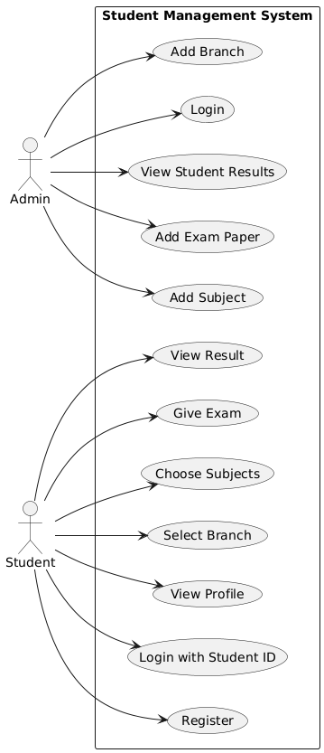

**Class Diagram (PlantUML)**

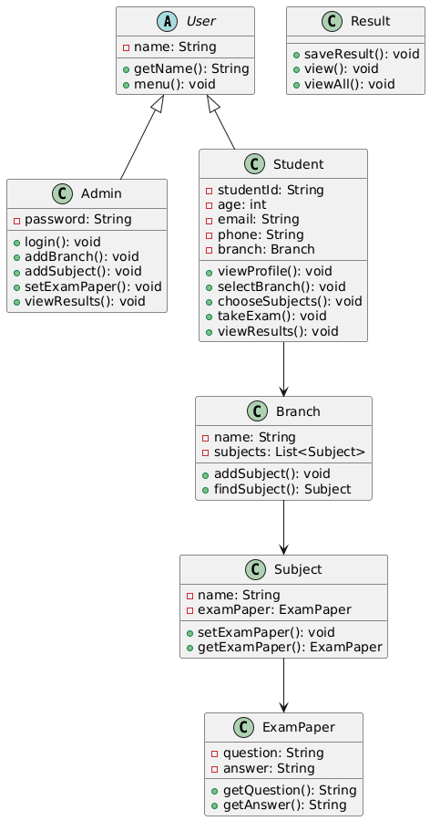

**System Flow Diagram (PlantUML)**

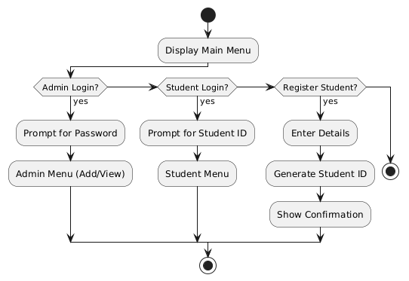

**Tools Used**

* Java 17+
* IntelliJ IDEA
* PlantUML for diagram modeling
* Git/GitHub for version control and collaboration

**Conclusion**

This requirement document outlines the functional flow, core class relationships, and user interaction for a Java-based command-line Student Management System. The system uses clean OOP design and is highly extensible for future academic features like grading, authentication, or file-